( NEW ITEM ) 2005

HDMI Digital Visual Cable
High-Definition Multimedia Interface Cable for Visual Equipments
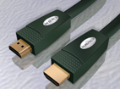
HDMI Digital Visual Cable (High-Definition Multimedia Interface Cable)
Features: * the FURUTECH HDMI Cable has successfully completed ATC Compliance testing at the HDMI Authorized Testing Center---Silicon Image.
* Main Wire used theα(Alpha) conductor( Silver platedμ–OFC) for ultra low transmission loss.
*HDMI Plug with α(Alpha) conductor and non-magnetism 24K Gold Plated, Body with Bronze 24K Gold Plated and non-magnetism, Sheath with Flexible PVC (Dark Green).
* 3 Lay Shielding appropriate for very superior high noise isolation.
* Production Length:1M/2M/3M/5M/7M/12M/15M .
*α(Alpha) conductor is the fine PCOCC conductor /μ–conductor orμ–OFC conductor wire strands and treated byα(Alpha) process.
Specifications ：Construction and Material of Cable
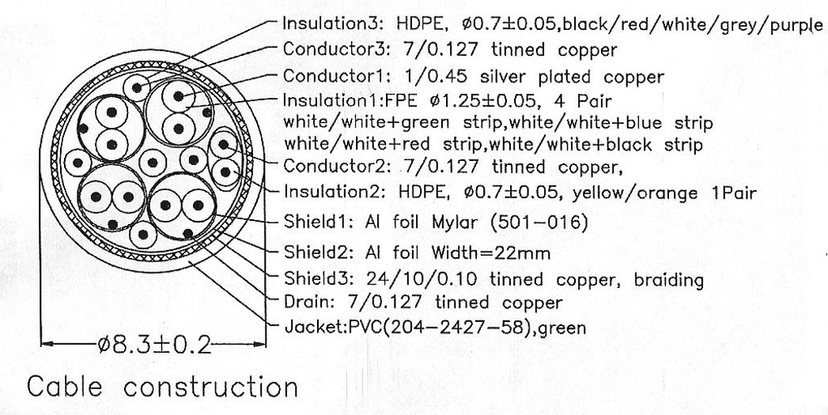
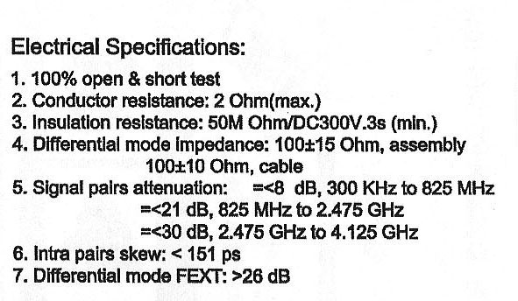

FURUTECH CO., LTD.
www.furutech.com
service@furutech.com

